**Output**:

Project : Practical5

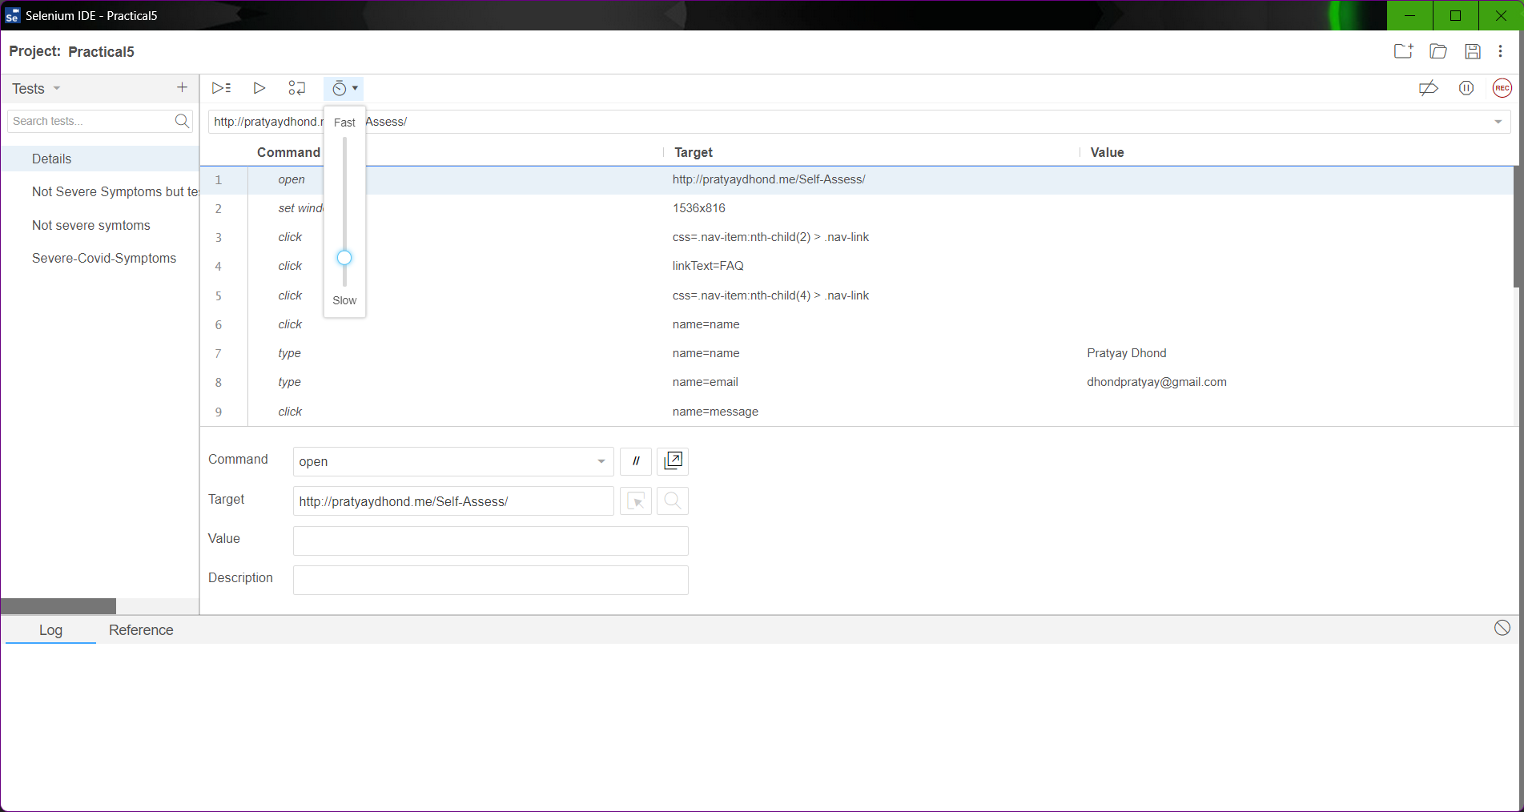

Selenium window with the four test cases

**Steps Common in all test cases:**

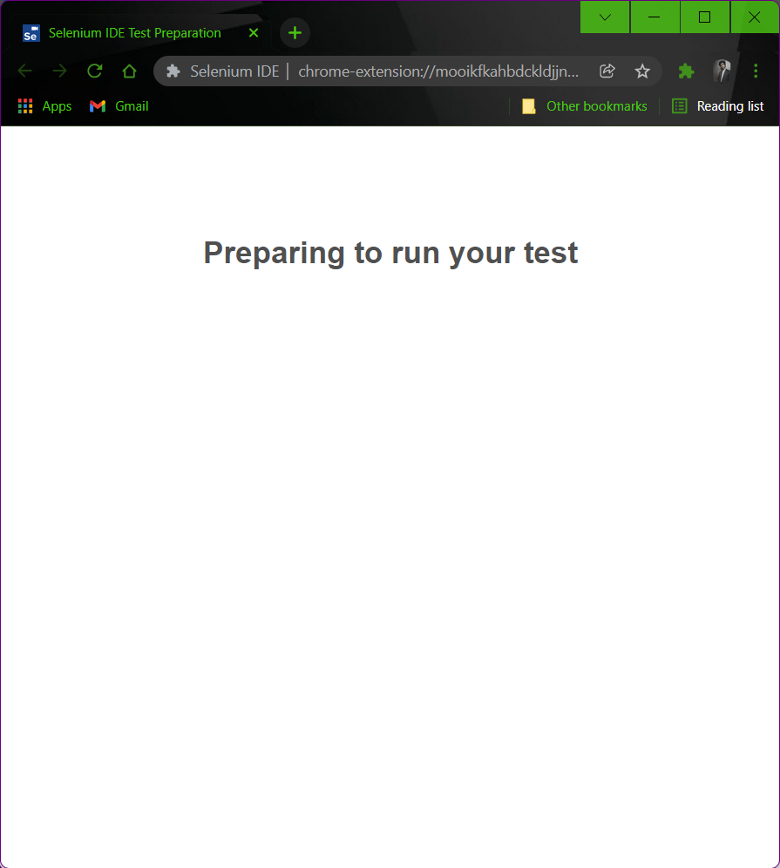

Selenium opens a new browser window

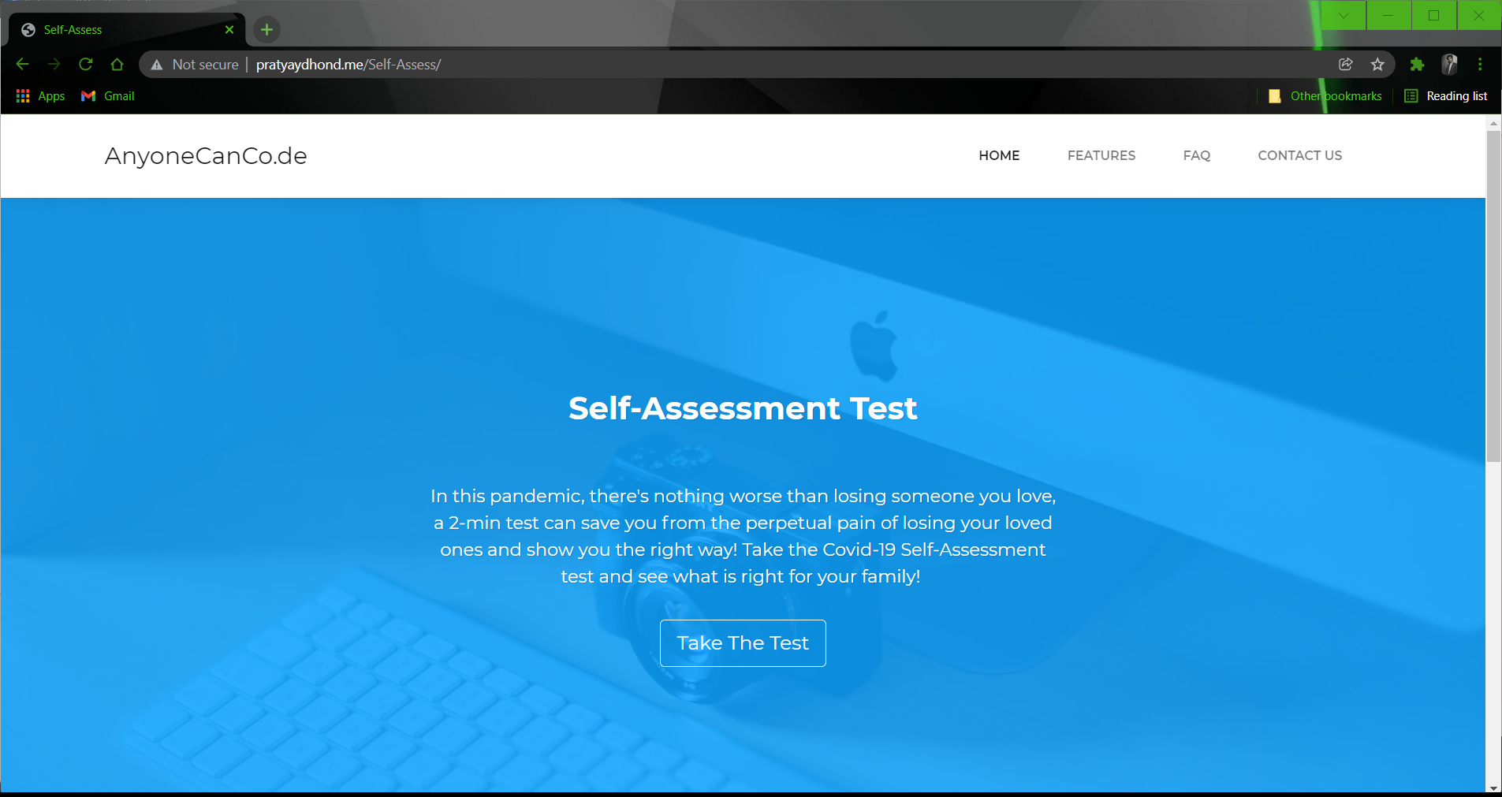

The site is loaded by selenium automation tool

**1)Test Case Name: Details**

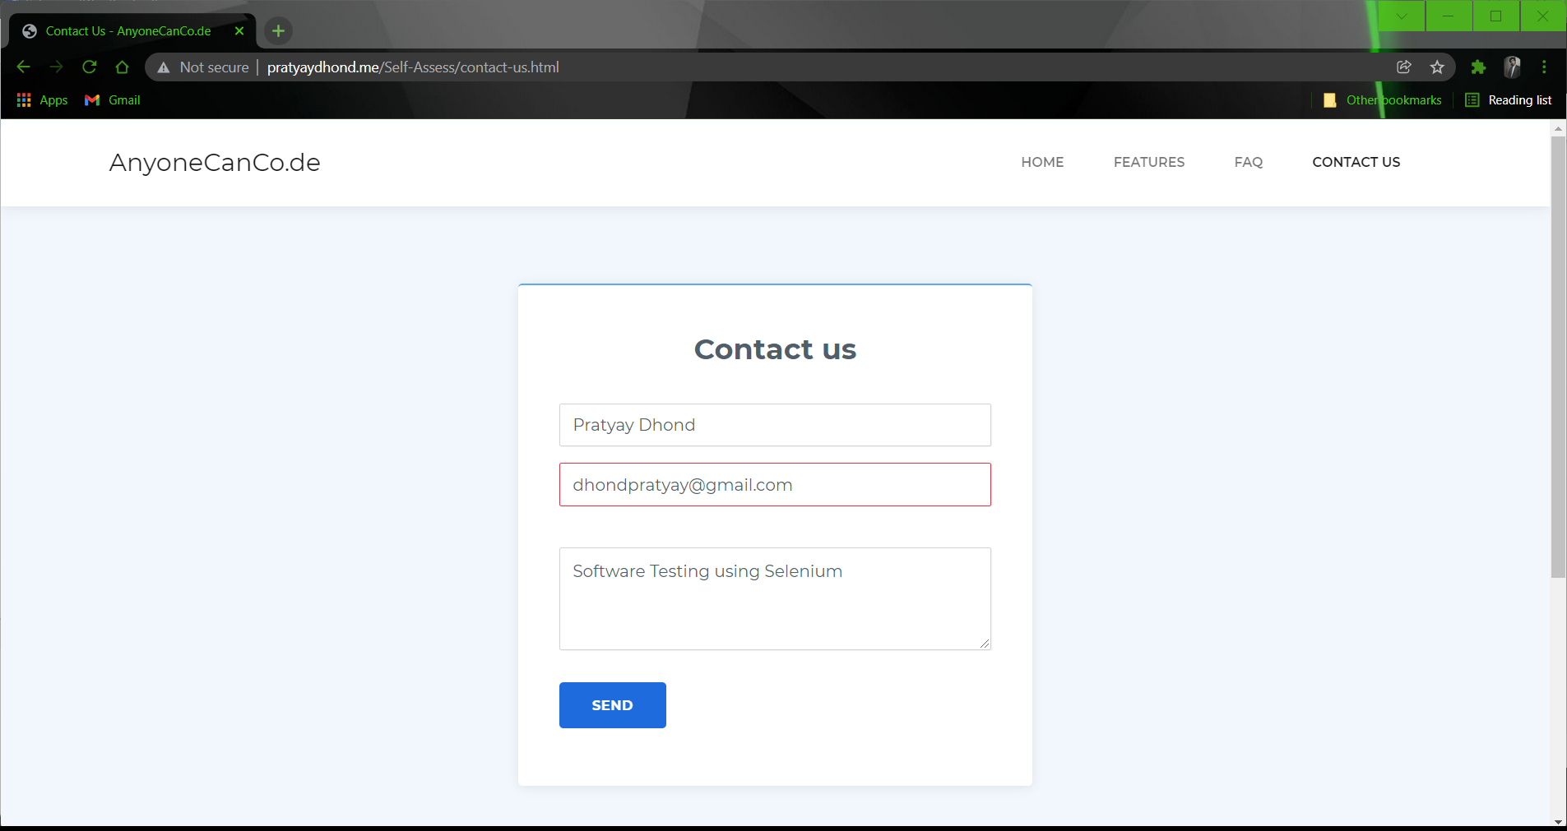

The fields are automatically filled by the tool

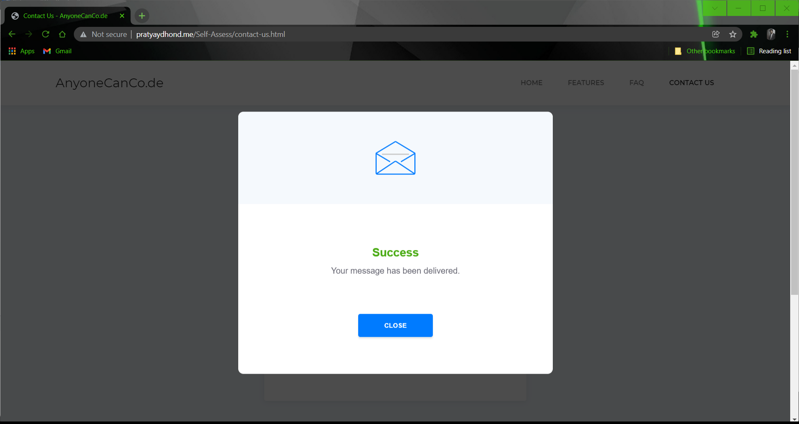

The tool sends the message.

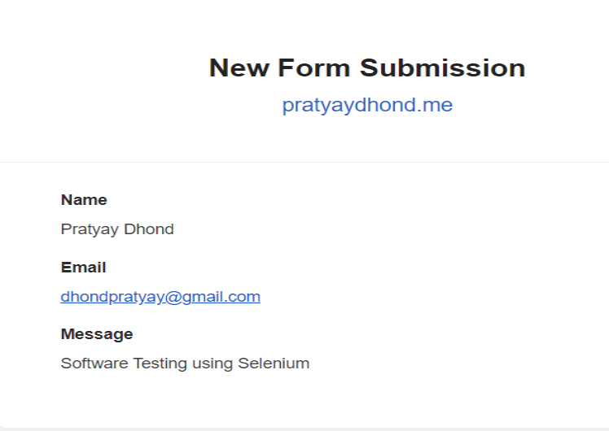

Input received in mail submitted by using the tool

**2)Test Case Name: Not Severe Symptoms but testing should be done**

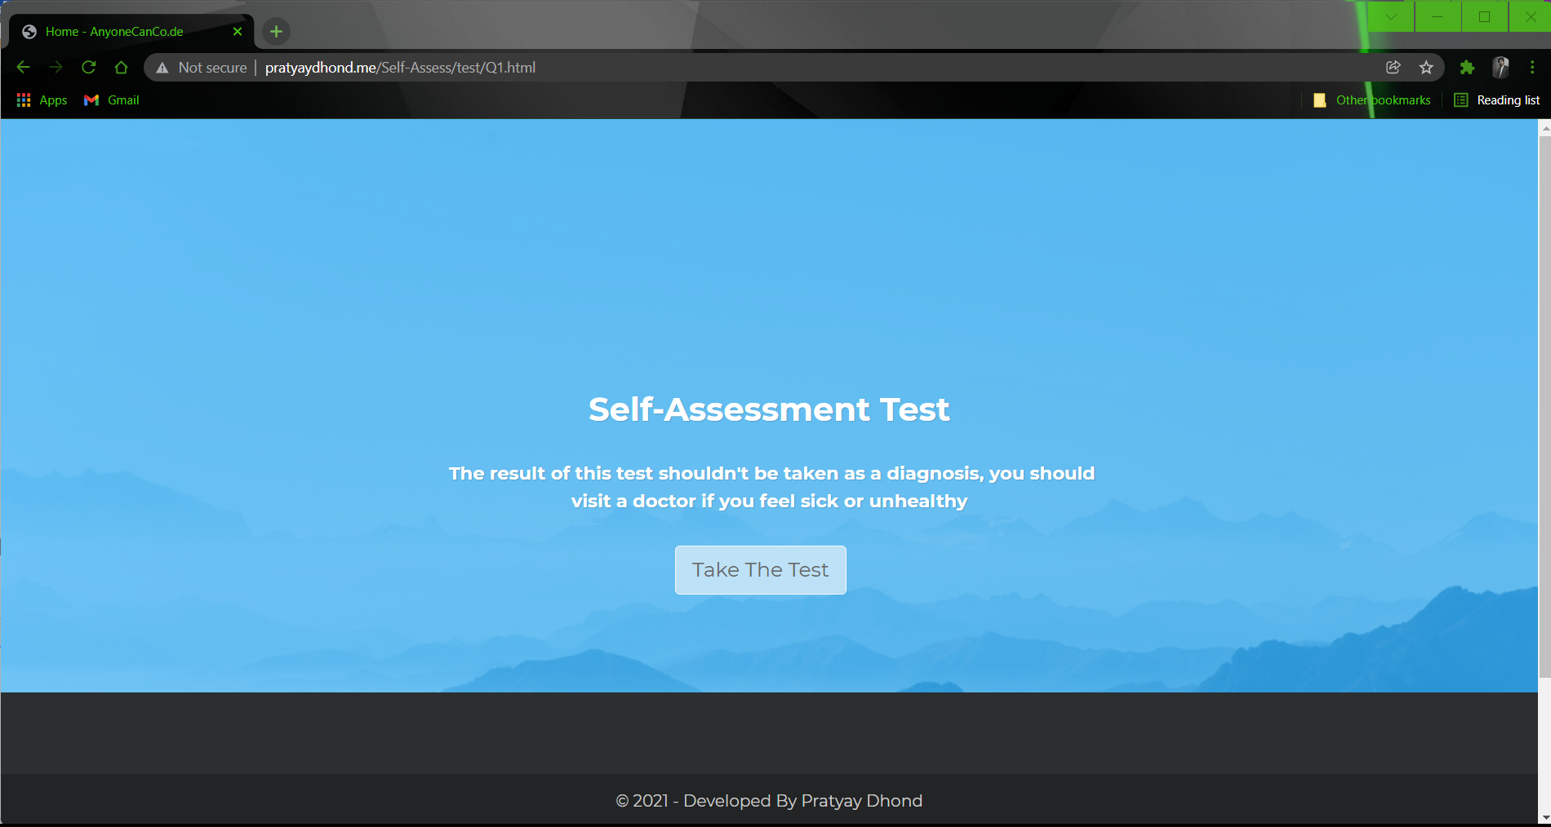

Self-Assessment test automation using selenium

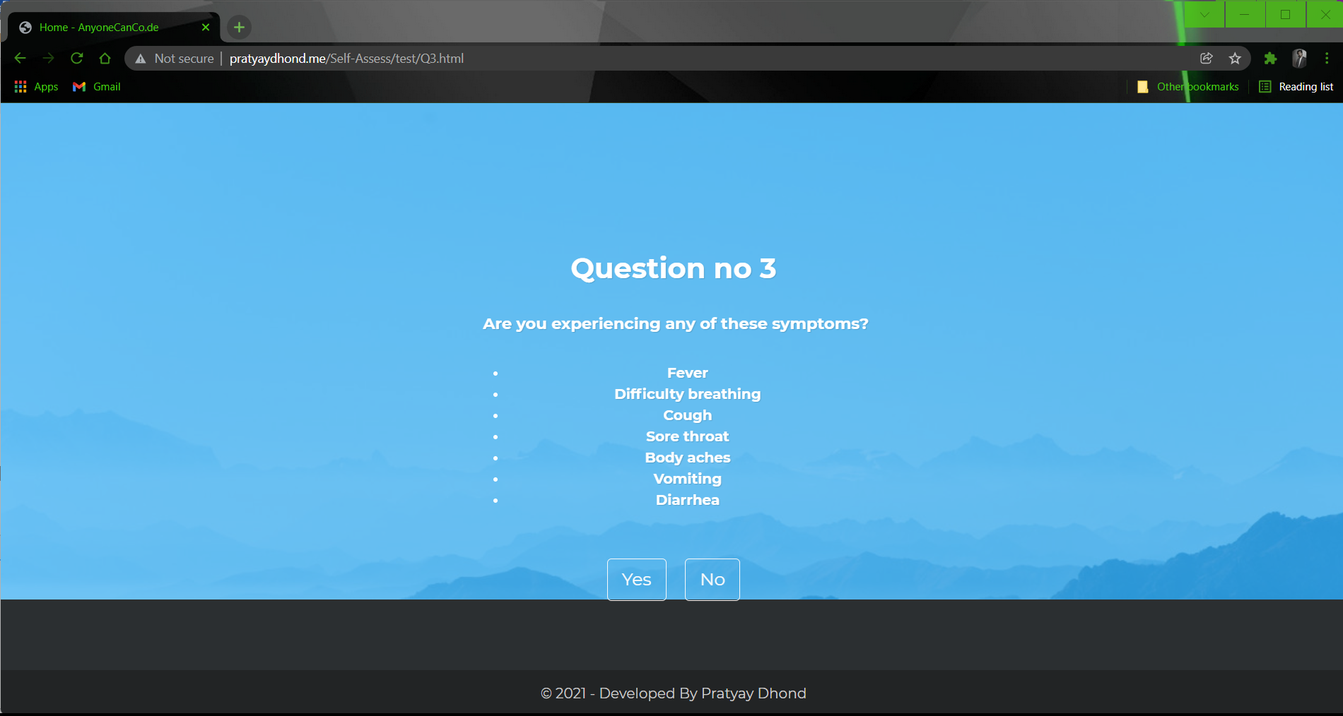

Answering Questions using Selenium(Selected Answer : Yes)

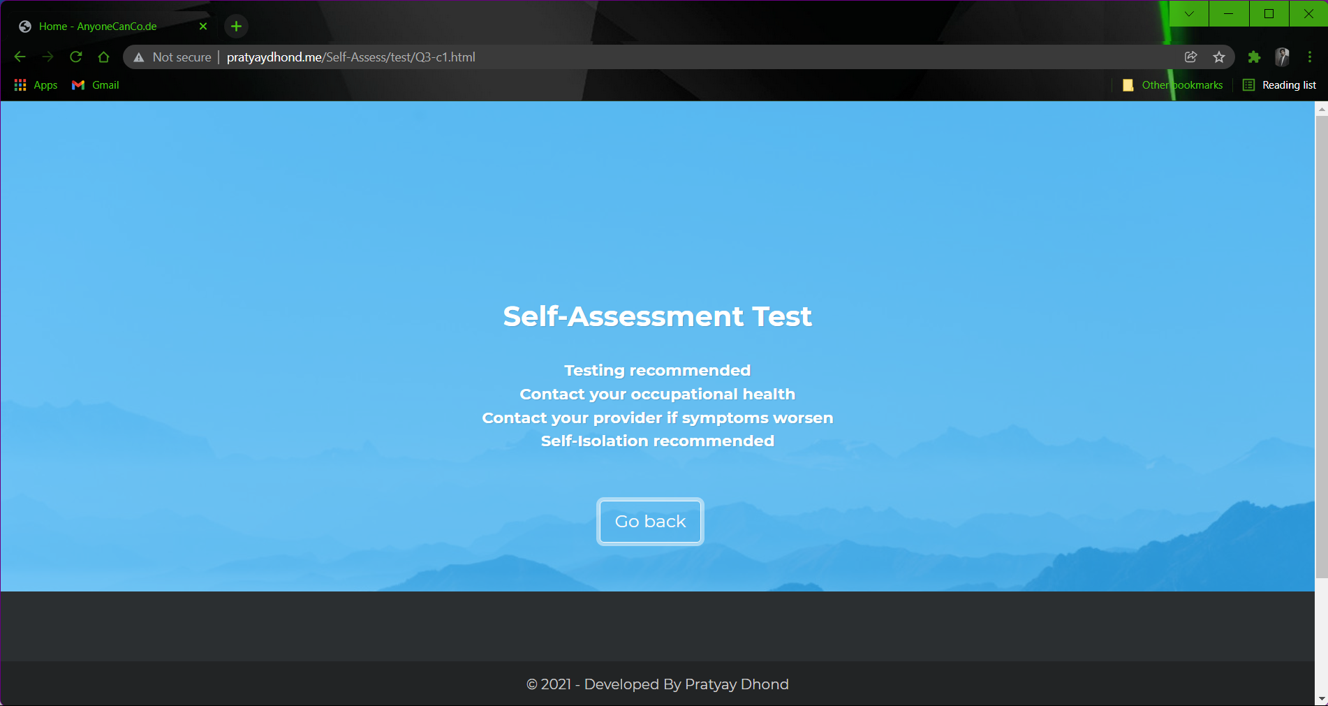

Self-Assessment test result generated by automation testing.

**3)Test Case Name: Not severe symptoms**



Self-Assessment test automation using selenium

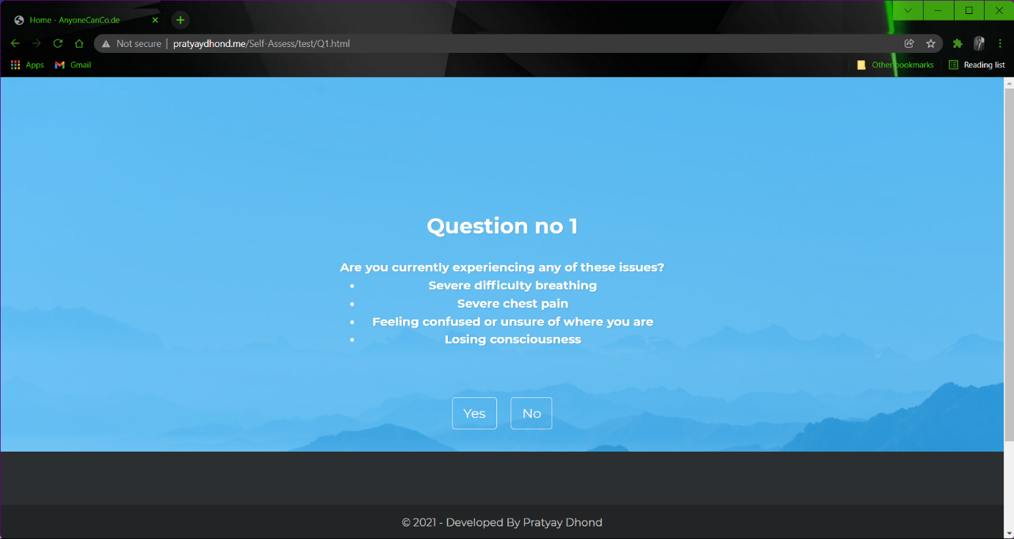Answering Questions using Selenium automation tool. (Selected Answer : No)

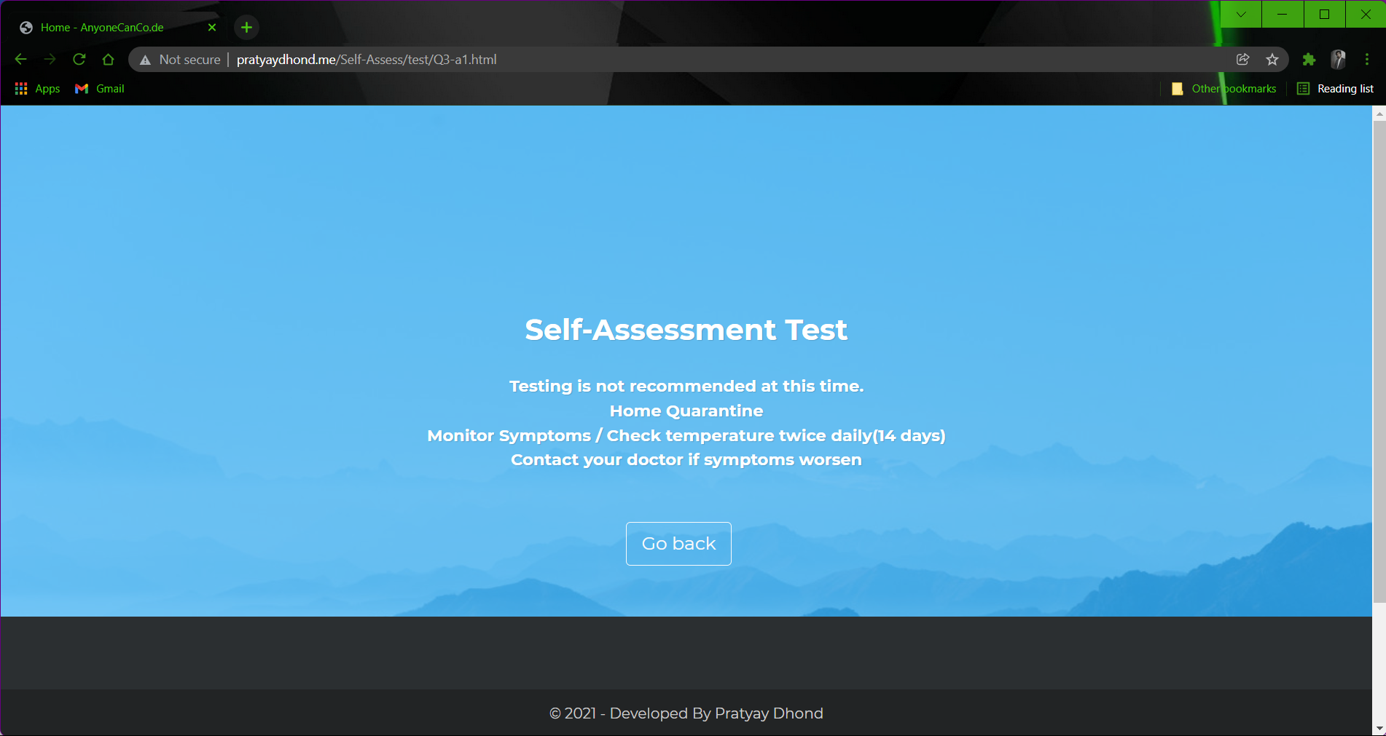

Self-Assessment test result generated by automation testing.

**4)Test Case Name: Severe-Covid-Symptoms**

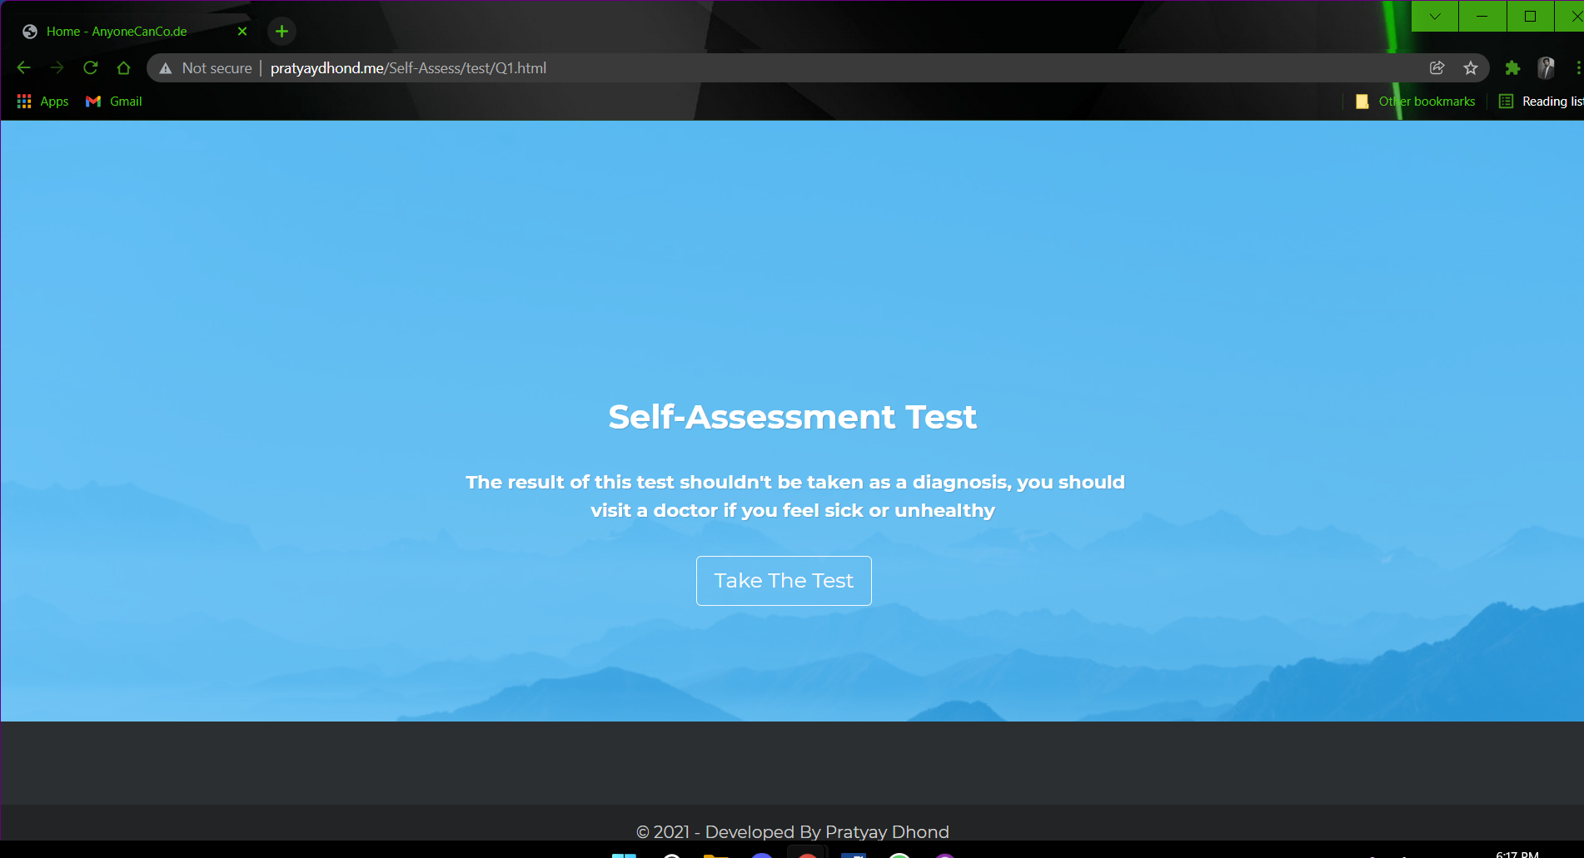

Self-Assessment test automation using selenium

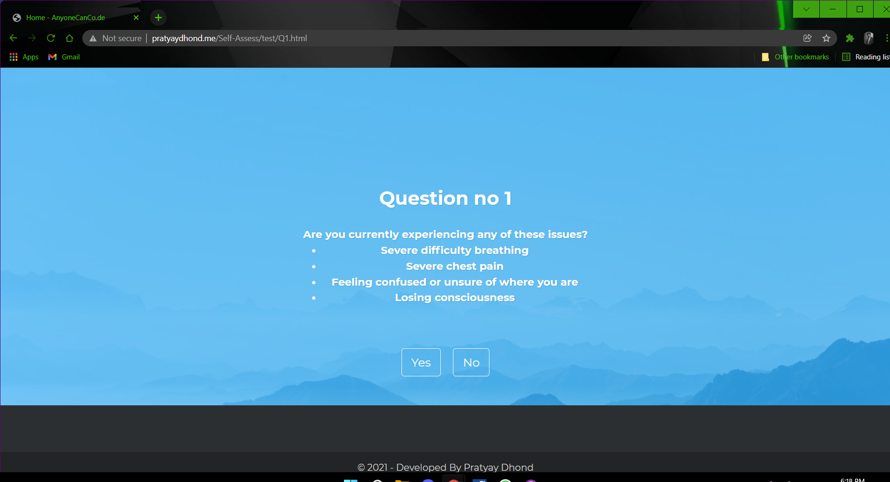

Answering Questions using Selenium automation tool. (Selected Answer: Yes)

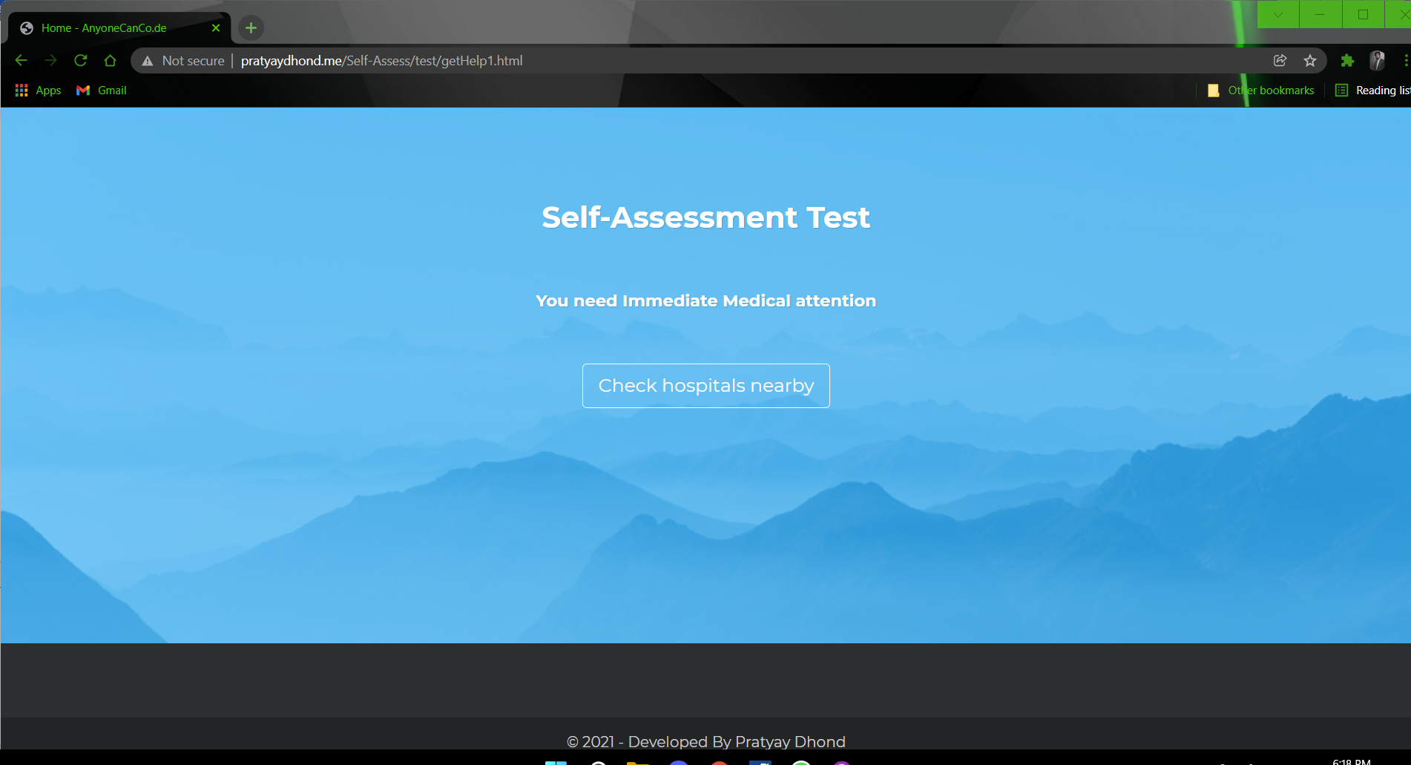

Self-Assessment test result

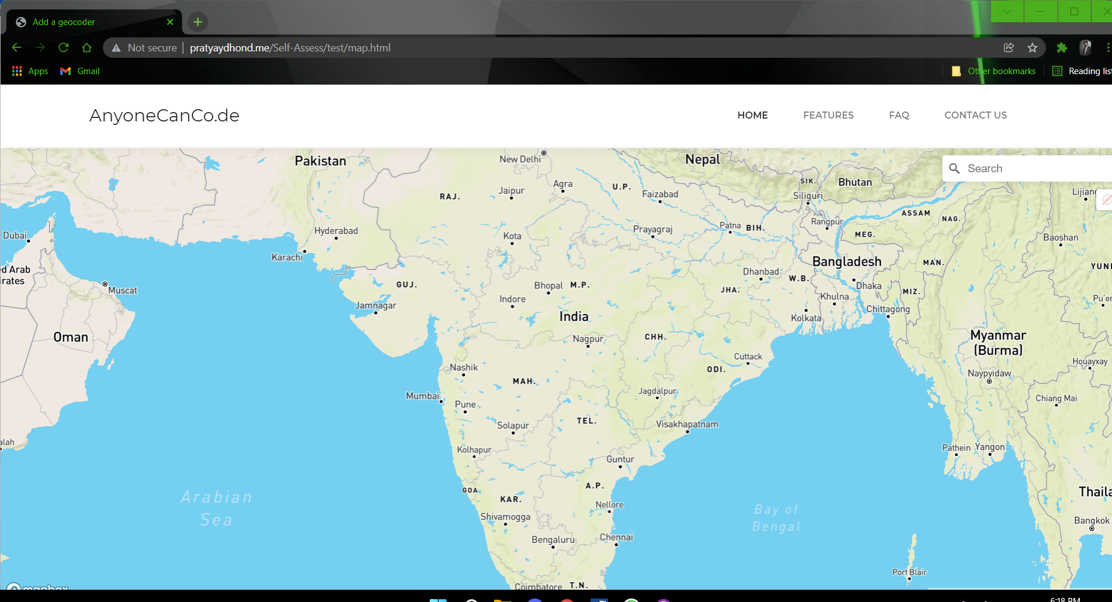

**Map for checking nearby hospitals using Selenium**